# Lab-9-2: AWS Cli

# Objectives

* Connect AWS EC2 from local computer
* Exploring AWS cli console



From Previous lab:

Task 1: Create an EC2 instance on AWS.

<https://www.awseducate.com>

go to classroom

aws console

select ec2

launch an instance

select ubuntu server 1804 (free tier eligible)

Task2: Connect your local computer to this vm

use putty gen to create access key

use putty to add the ppk file to putty

for IAM documentation

<https://docs.aws.amazon.com/IAM/latest/UserGuide/introduction.html>

--------------------------------------------------------------------------------------------------

**Today:**

**Task 3:** Observe IAM configuration details in AWS Management console

Go to IAM service, and select users

Find the Json version of the user policy for the user

**Q1** What does this policy allow?

It does not permit anyone looking at the policy

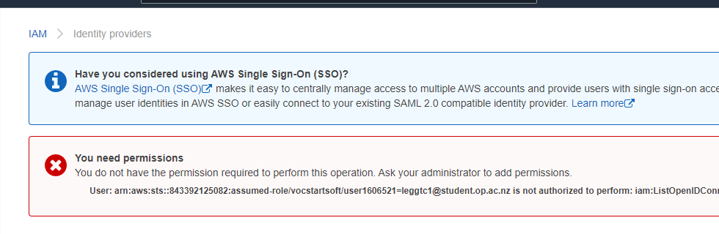

**Task 4:** Configure AWS cli to connect to your account

Run *aws configure* on your AWS instance

Set aws default region us-east-1 (if needed), output format as json

Retrieve the account details from the following screen

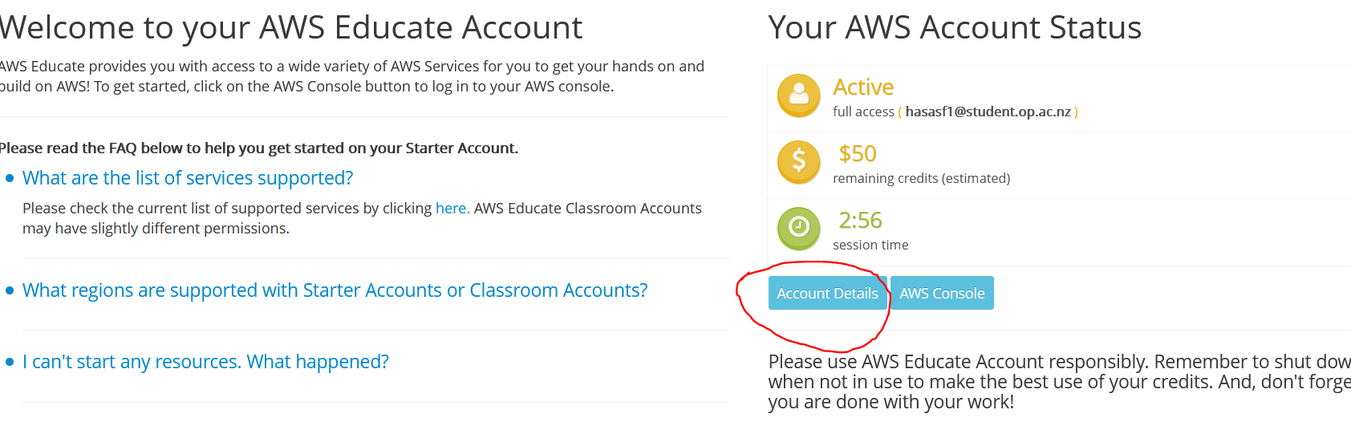

Click account details, and then show button

Copy the credentials as directed and past it onto your AWS instance that you created before.

On your AWS instance run *aws iam list-users*

**Q2**. What do you see? Does it match with the information you found earlier?

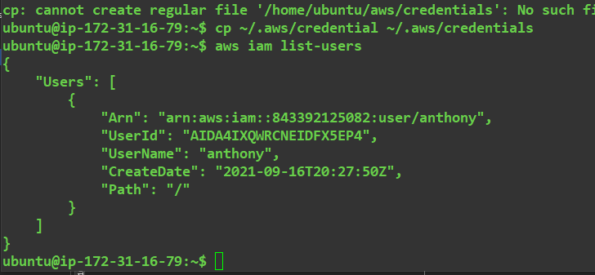

**Challenge Task:** Find policy file through aws cli and generate it in a json file

Earlier you saw a policy file related to the user account.

You need to find that policy file through aws cli.

Use aws cli documentation to do this activity

<https://docs.aws.amazon.com/cli/latest/reference/iam/index.html>

Hints: You may need to run multiple commands to get this done

Use list-policies, get-policy commands

You may need to know the policy Arn and version to run get-policy

